**Abstract**

Neuro-psychological testing is a time-consuming process fraught with experimenter variability and bias. Several of these errors can be reduced by automating the process of behavioral testing. The construction presented here allows for automation of rat behavior on a T-maze task including spatial reversals hopefully alleviating several of these issues.

**Introduction**

Neuropsychological testing is performed through a variety of behavior tests, of which one of the most popular is the T-maze task. While the procedure to perform this test has been well defined, it is prone to a large degree of experimenter bias and variability. Anecdotal evidence exists that rats with a high affinity for an experimenter develop a spatial bias to move towards the arm nearest the experimenter. The converse is also true. Furthermore, spatial testing often wastes several hours of an experimenter’s day, time that could be better spent performing analyses on collected data.

To this end, previous work from our laboratory was able to develop an automated T-maze capable of running spatial reversal tasks. The original model allowed for rats to be unsupervised and allowed almost double the number of trials to be run as by hand. However, this original model contained several design problems when it was acquired. In the original model, numerous wires were found without a connection. Further, the original model contained several analog switches were digital switches would have sufficed. In addition, the original code for control of the maze had numerous issues including poor variable design, redundancy errors, and incomplete utilization of the tools present within the software. To make a more efficient maze, we have removed several of the design flaws present in the original model necessitating creating new wiring for much of the maze and significantly rewritten portions of code to enable more user control.

**Maze Description**

The maze design is described below. A parts list is presented in Table 1. Commented code is appended at the end of this chapter.

***Physical Construction of the Maze***

A diagram of the maze is presented below (Fig. 1). The construction of the components is described there.

Each holding chamber within the maze contained a nozzle delivering 10% sucrose solution, and three 100 mA LEDs indicating reward availability. Sucrose was held above the solenoid valve (McMaster) in a chamber (McMaster). The container was mounted to a plate at the exact height of the holding chamber. Opening the solenoid valve for about 50 milliseconds at the height was found to deliver roughly 100 μL of reward solution.

Several infrared sensors were placed throughout the T-maze allowing for efficient tracking of rat position. Sensors transferred signals to Arduino slave microcontrollers and an Arduino Mega 2560 controller allowing for appropriate parsing of the data using custom code (presented at chapter end).

MOSFET and NPN bipolar transistors were used to allow for placement of several LED lights throughout the track to guide animals and provide visual cues as needed for specific testing tasks.

***Wiring of the Maze***

A complete circuit diagram of the maze is presented in Fig. 2.

***Maze Coding***

All code used in this maze is commented and presented with the file title at the end of this chapter.

***Parts List***

A full parts list of the components used is presented below.

**Table 1 – Parts List of the components used in the maze construction.**

|  |  |  |
| --- | --- | --- |
| *Description* | *Component* | *Vendor* |
| Slave Microcontroller | Arduino Uno | Arduino |
| Maze Microcontroller | Arduino Mega 2560 | Mouser |
| Maze Computer | Pcduino3 - DevBoard | Mouser |
| Stepper Motor | Nema-17, Bipolar 1.7A/Phase | Pololu |
| Stepper Motor Driver | DRV8825 | Pololu |
| MOSFET Transistor | IRFZ44NPBF | Mouser |
| Infrared sensors | Sharp GP2Y0D810Z0F Digital Distance Sensor  10 cm | Pololu |
| Maze Arms | 3” Aluminum Channel | Servocity-Actobotics |
| Maze Walls | 1.5” Aluminum Pattern Plates | Servocity-Actobotics |
| NPN Bipolar Transistors | PN2222 | Mouser |
| Solenoid Valve | 5077T124-430  Stainless steel actuated On/Off Valve for Food and Beverage, 12 V DC, 1/8 NPT Female, 325 maximum PSI | McMaster-Carr |
| Tubing Fittings | Durable Nylon Extra-Grip babrbed tube fitting straight for ½” Tube input device x ½ Male pipe size | McMaster-Carr |
| Reward Tubing | Masterkleer PVC Clear tubing ½” input device, 5/8” output device | McMaster-Carr |
| Reward Reservoir | Oil reservoir, 5 oz capacity, 1/8: NPTF male Outlet | McMaster-Carr |
| Plastic Floor | Optically clear cast acrylic rectangle bar, 3” x 4’ x 1/8” | McMaster-Carr |
| Platform Cylinders | 60 quart Standard Weight Aluminum Stock Pot (40760385) | Webstaurant Store |

**Discussion**

The automated maze presented here is an improvement of the previously existing model. It allowed for the collection of trial-wise data included with the rest of this dissertation. All code and construction designs are available upon request to Dr. Matthew Shapiro for others who may be interested in implementing a similar construction in their laboratories.

**Figures and Legends**

***Figure 1. Maze Dimensions and Pathways.*** The overall maze architecture is described above. Each pathway shown in the diagram is 3” wide. The holding chamber has an 8” radius and a 16” height (found previously to prevent escape of rats during the intertrial interval). The opening from the holding chamber to the main maze is 3” wide. The holding chambers are mounted on a lazy Susan (McMaster) allowing for rotation of the chamber. The rotation of the chamber is accomplished using a stepper motor (Nema-17, Bipolar 1.7A/Phase, Polulu). The maze is covered by Plexiglass (McMaster) sharing the dimensions of the portions covered except the holding chambers themselves.

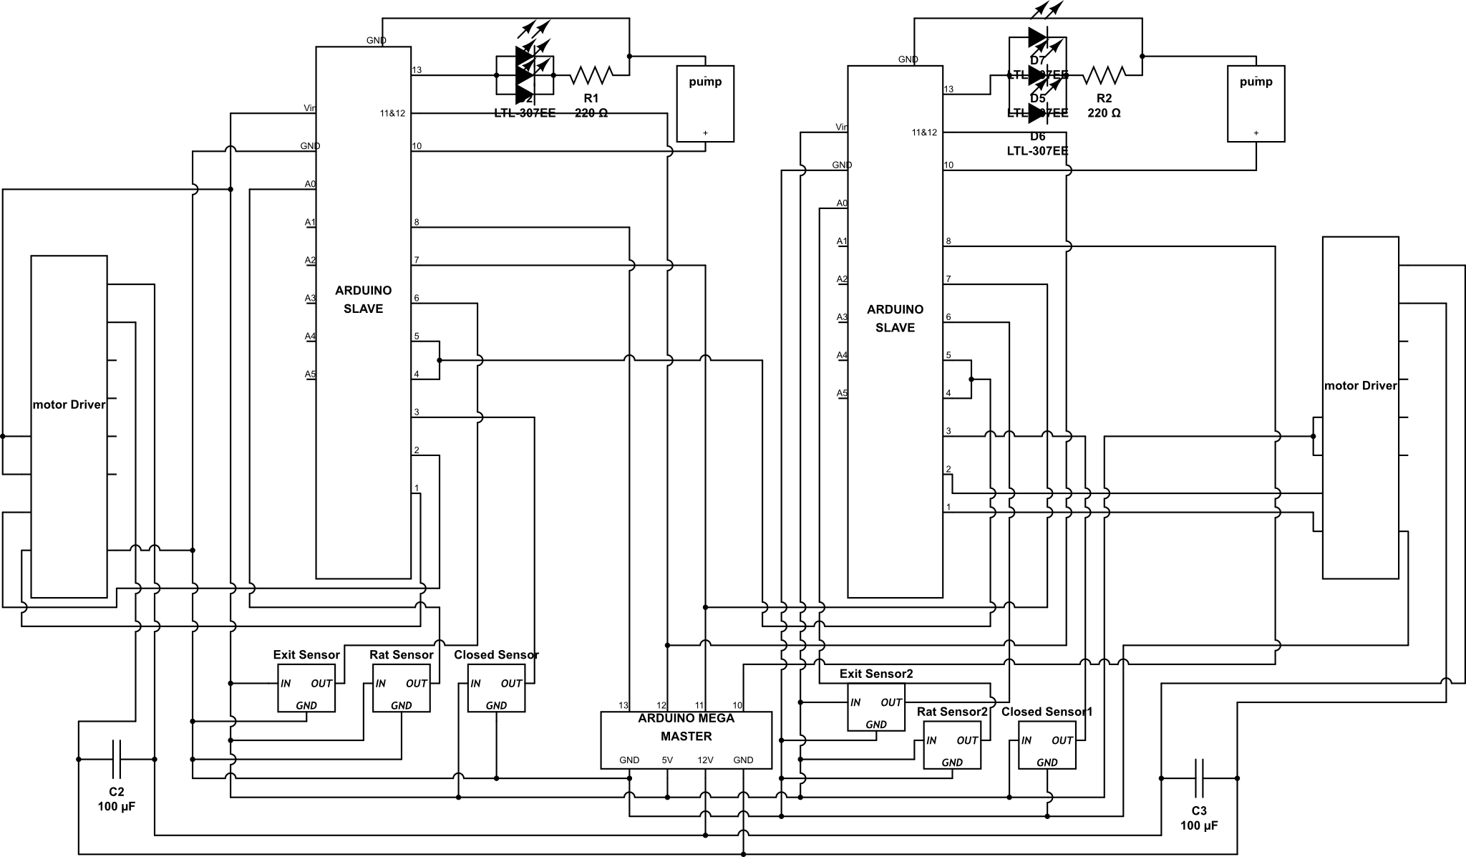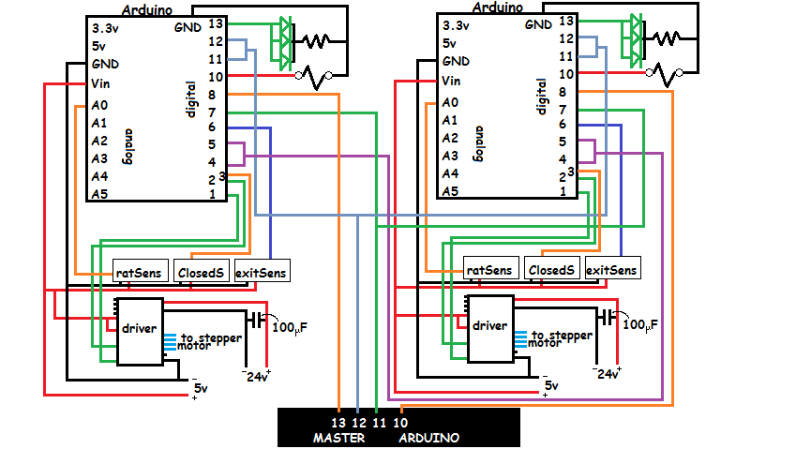

***Figure 2. Circuit Diagram of the Maze.*** A labelled circuit diagram containing all components used for the maze is presented.

**Code:** <https://github.com/avastJudast/Hypermaze>